**Assignment 4 : Create Stored procedure in Northwind database to insert or update a record in a table**

**1. Create a stored procedure in the Northwind database that will calculate the average value of Freight for a specified customer.Then, a business rule will be added that will be triggered before every Update and Insert command in the Orders controller,and will use the stored procedure to verify that the Freight does not exceed the average freight. If it does, a message will be displayed and the command will be cancelled.**

**Ans:-**

CREATE PROC average_freight_order

@cid NCHAR(5), @Freight MONEY

AS

BEGIN

DECLARE @avgfreight MONEY

SELECT @avgfreight = AVG(Freight) FROM Orders GROUP BY CustomerID HAVING CustomerID = @cid;

IF @Freight > @avgfreight

BEGIN

PRINT 'Freight value is greater than average value';

RETURN

END

END

EXEC average_freight_order 'ALFKI',5

**Output:-**

Commands completed successfully.

EXEC average_freight_order 'ALFKI',500

**Output:-**

Freight value is greater than average value

**2. write a SQL query to Create Stored procedure in the Northwind database to retrieve Employee Sales by Country**

**Ans:-**

Create Proc Employee_Sales_by_Country

As

Begin

select e.FirstName,e.LastName,e.Country,sum(os.subtotal)'Sales' from [Orders] o join [Order Subtotals] os on o.OrderID=os.OrderID join

Employees e on o.EmployeeID=e.EmployeeID

group by e.Country,e.FirstName,e.LastName

end

execute Employee_Sales_by_Country

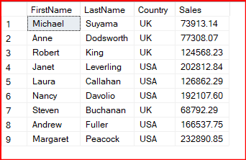**Output:-**

**3. write a SQL query to Create Stored procedure in the Northwind database to retrieve Sales by Year**

**Ans:-**

Create Proc Sales_by_Year

AS

Begin

select YEAR(o.OrderDate) 'Year' , Sum(os.Subtotal)'Sales by Year' from Orders o join [Order Subtotals] os on o.OrderID=os.OrderID

group by YEAR(o.OrderDate)

end

execute Sales_by_Year

**Output:-**

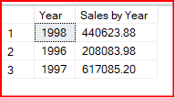

**4. write a SQL query to Create Stored procedure in the Northwind database to retrieve Sales By Category**

**Ans:-**

Create Proc Sales_by_Category

AS

Begin

select sc.CategoryName, Sum(sc.ProductSales)'Sales by Category' from [Sales by Category] sc group by sc.CategoryName

end

execute Sales_by_Category;

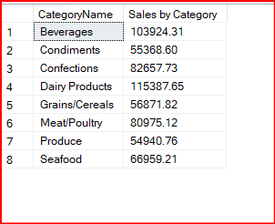**Output:-**

**5. write a SQL query to Create Stored procedure in the Northwind database to retrieve Ten Most Expensive Products.**

**Ans:-**

Create Proc Ten_Most_Expensive_Products

AS

Begin

select top 10 ProductName,UnitPrice from Products order by UnitPrice desc

end

execute Ten_Most_Expensive_Products;

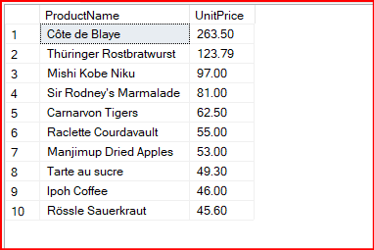**Output:-**

**6. write a SQL query to Create Stored procedure in the Northwind database to insert Customer Order Details.**

**Ans:-**

create proc insert_cust_order_deltail

@orderid int, @productid int ,@unitprice money,@quantity smallint ,@discount real

AS

Begin

insert into [Order Details] values (@orderid,@productid,@unitprice,@quantity,@discount)

End

execute insert_cust_order_deltail 11076,76,45,13,0.025;

**Output:-**

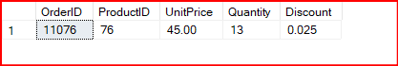

**7. write a SQL query to Create Stored procedure in the Northwind database to update Customer Order Details**

**Ans:-**

create proc update_cust_order_deltail

@oid int,@pid int, @unitprice money,@quantity smallint ,@discount real

AS

Begin

update [Order Details] set UnitPrice=@unitprice, Quantity=@quantity,Discount= @discount

where OrderID=@oid and ProductID=@pid

End

execute update_cust_order_deltail 11076,76,50,19,0.027;

**Output:-**

